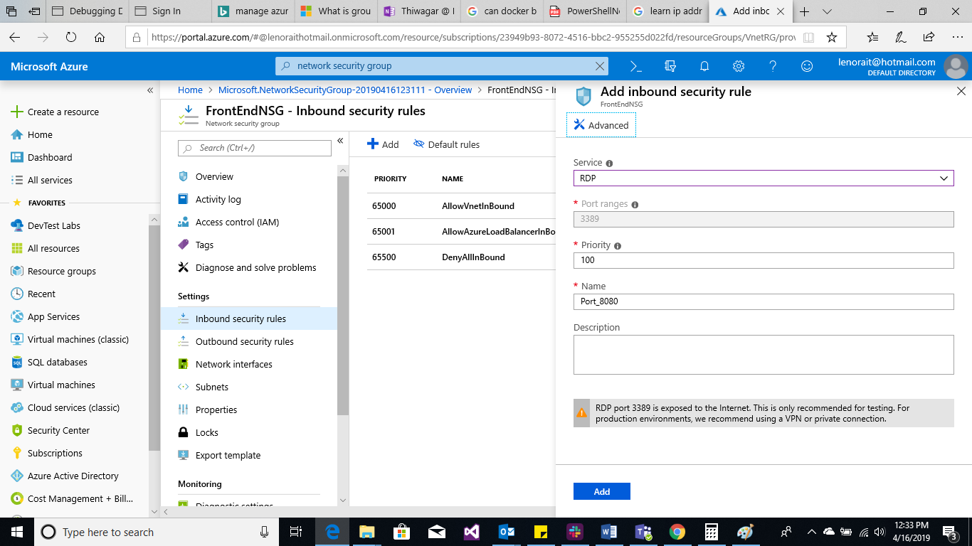

Front end NSG rule for RDP.

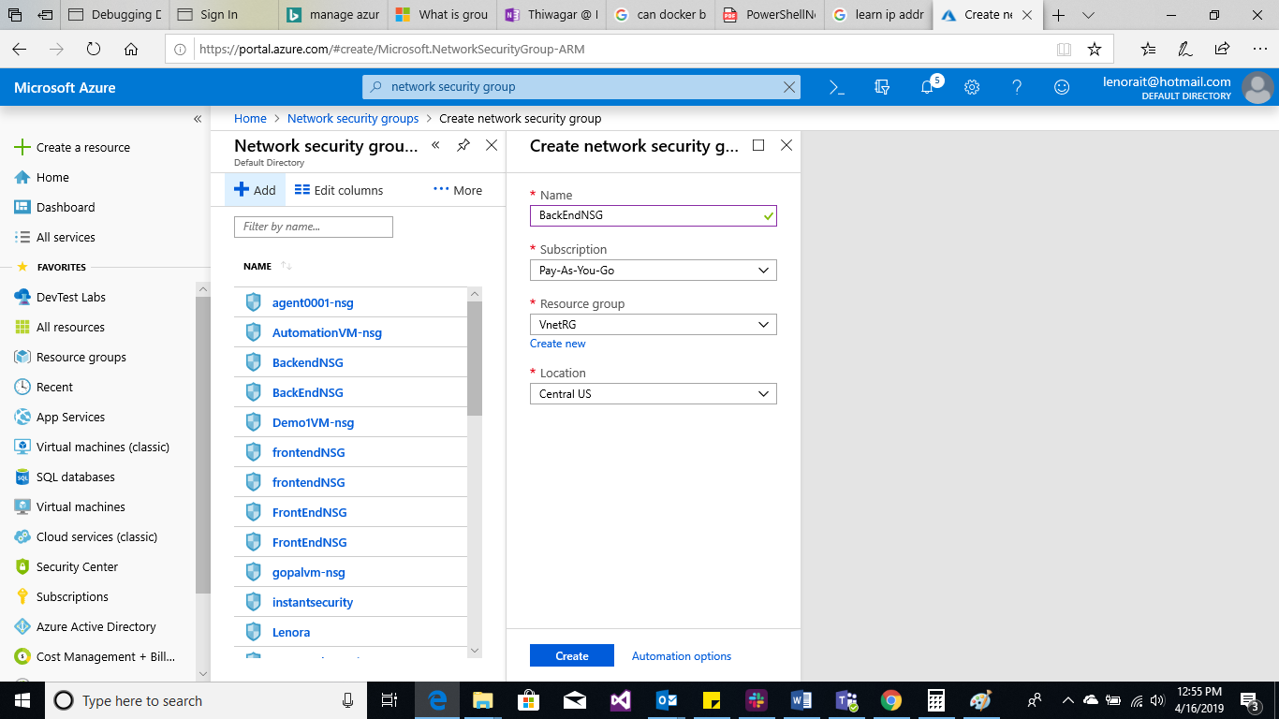

Created BackEnd NSG on VnetRG.

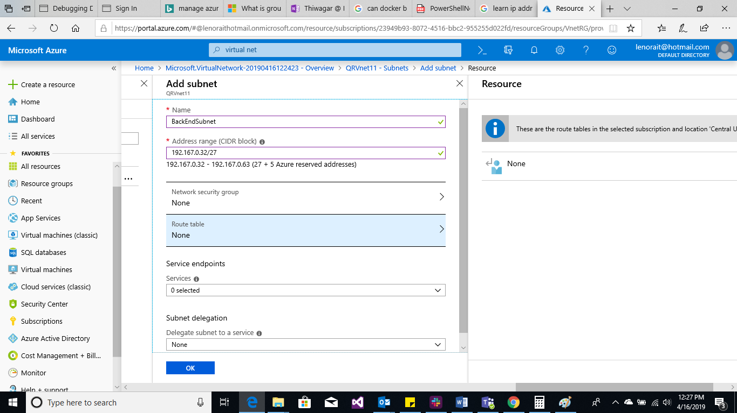

Added NSG to a subnet.

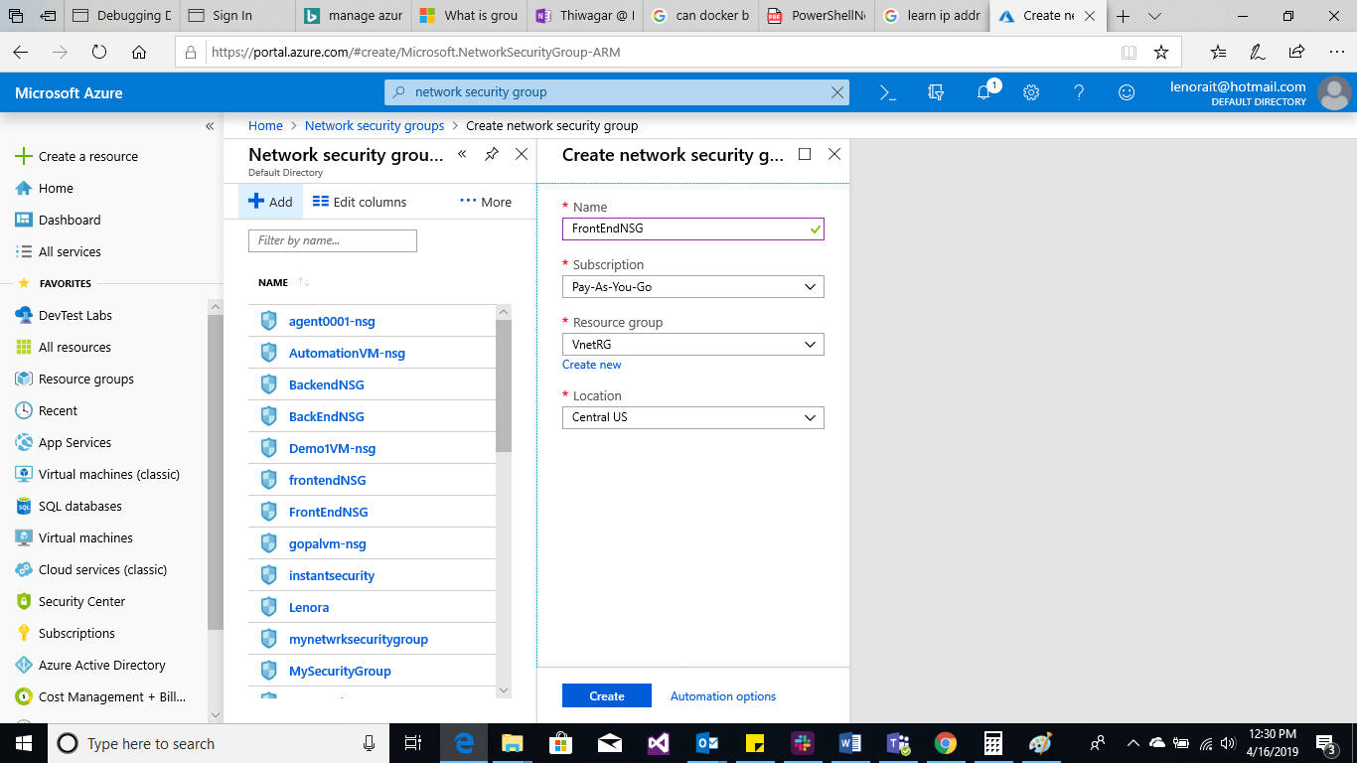

Created front end NSG.

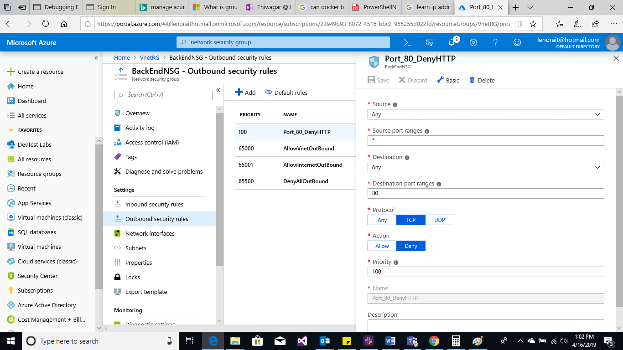

Deny rule for BackEndNSG, port http.

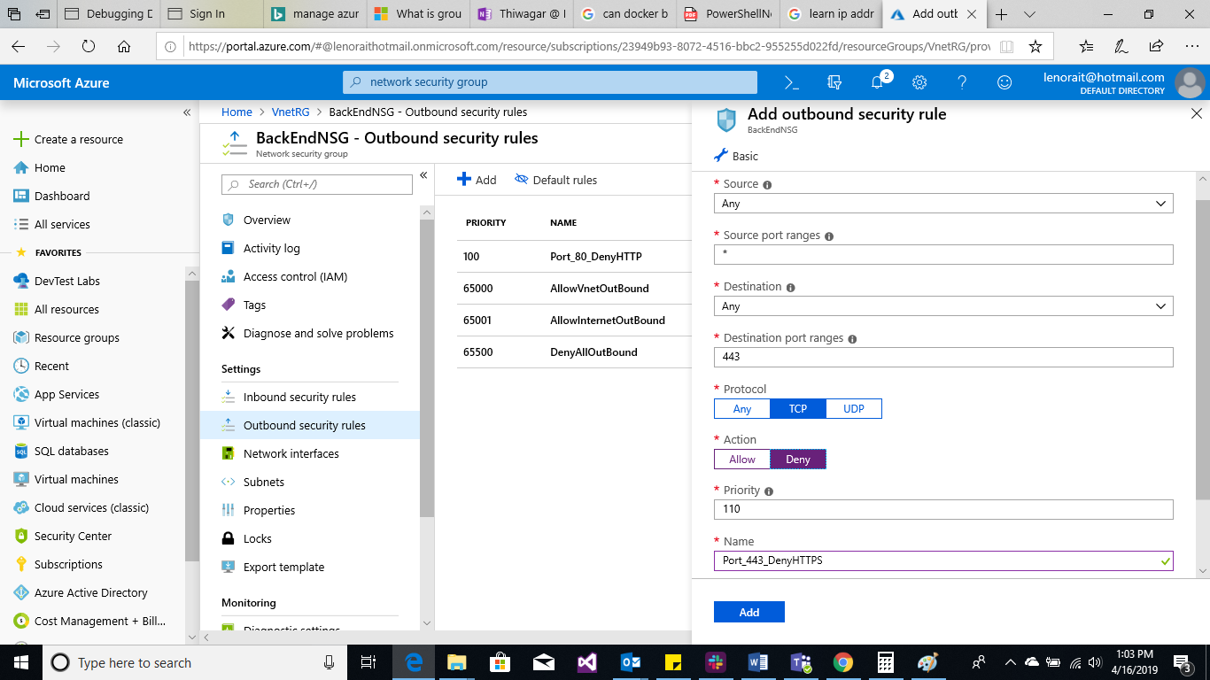

Deny rule for BackEndNSG, port http.

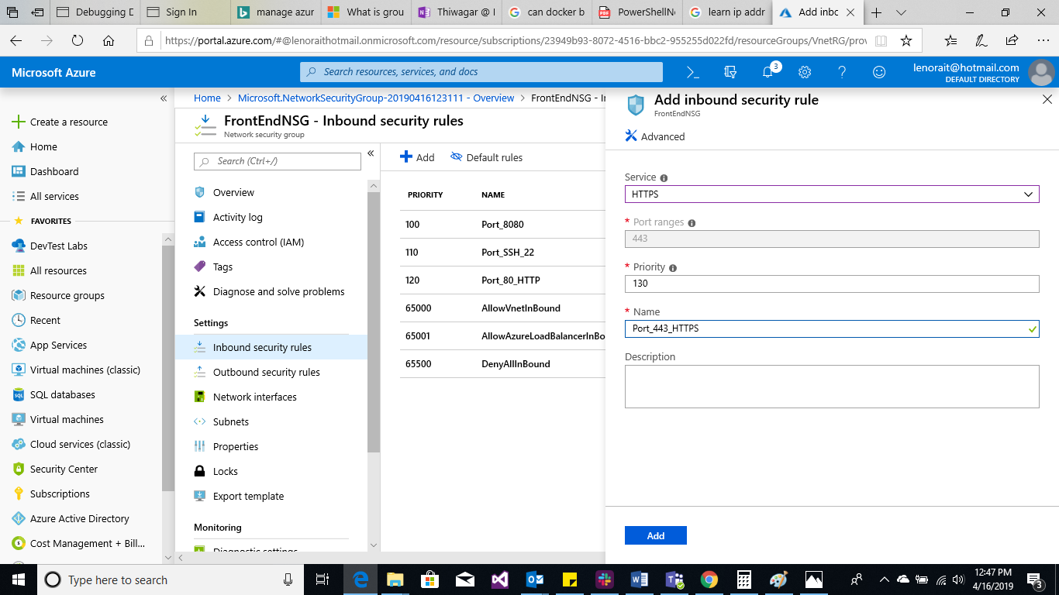

Front End NSG for Port 443 https.

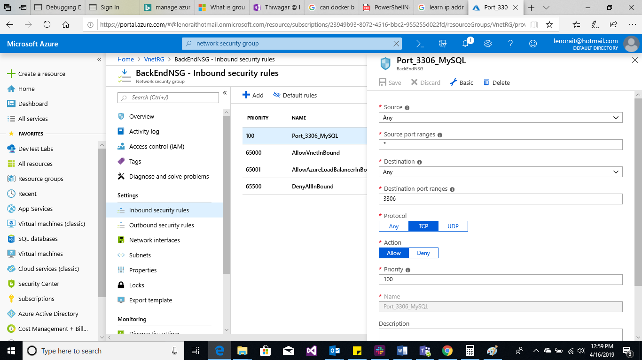

Back end NSG for 3306 MySQL Outbound Security rule.

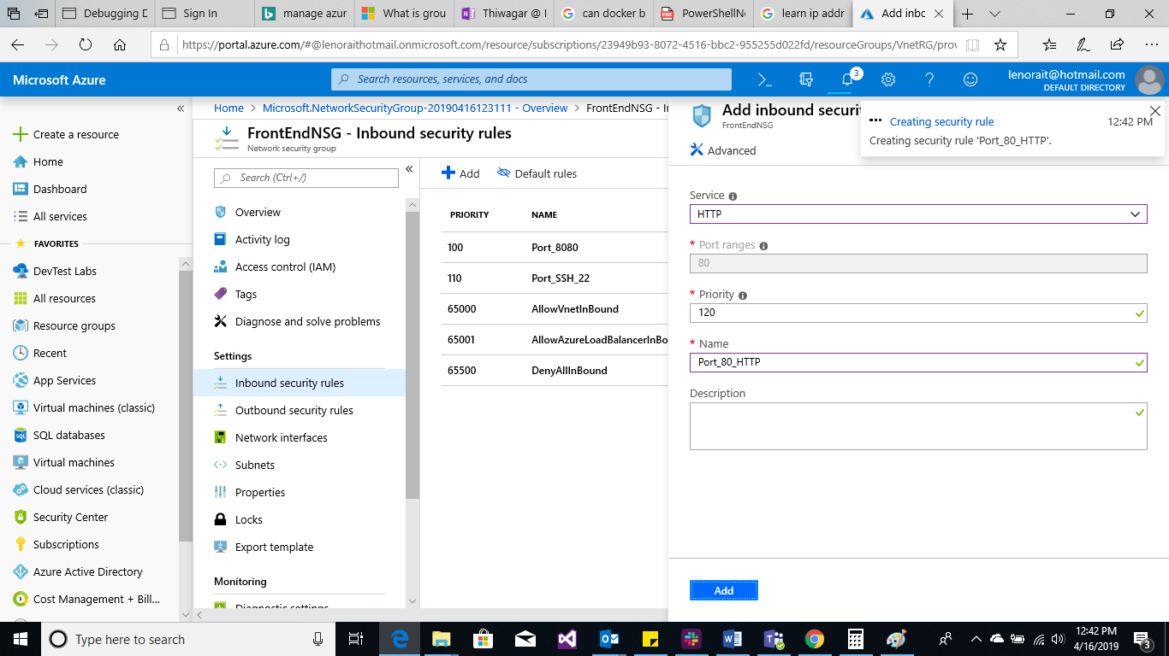

Front End NSG – Inbound security rule for http port 80.

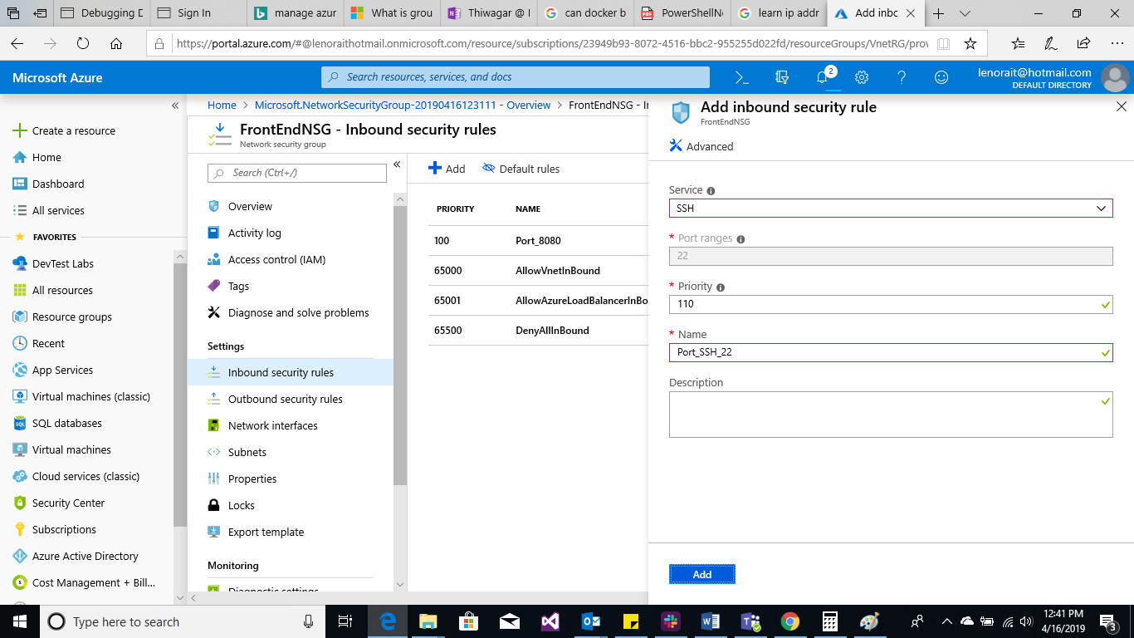

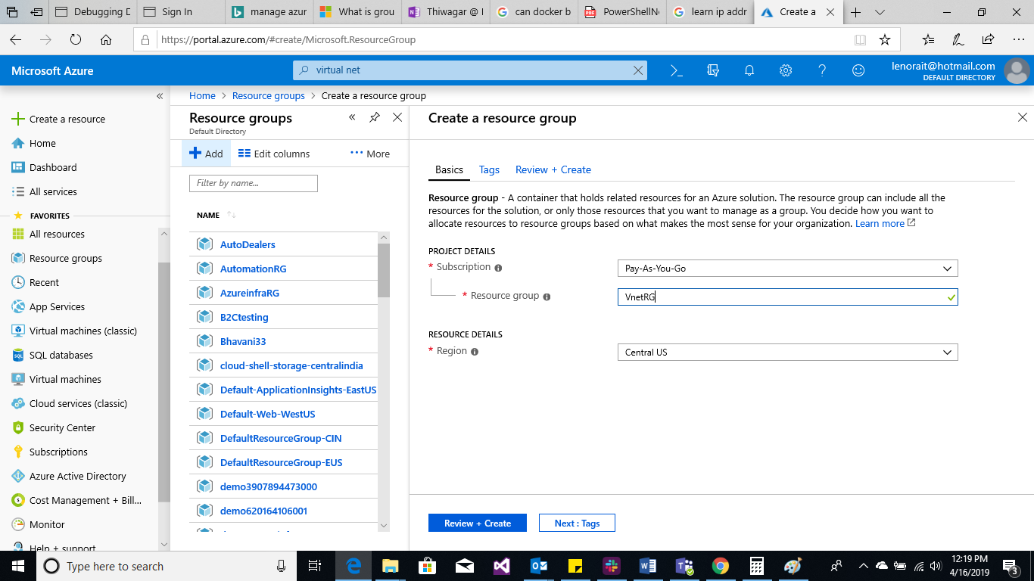

Created a resource group VnetRG

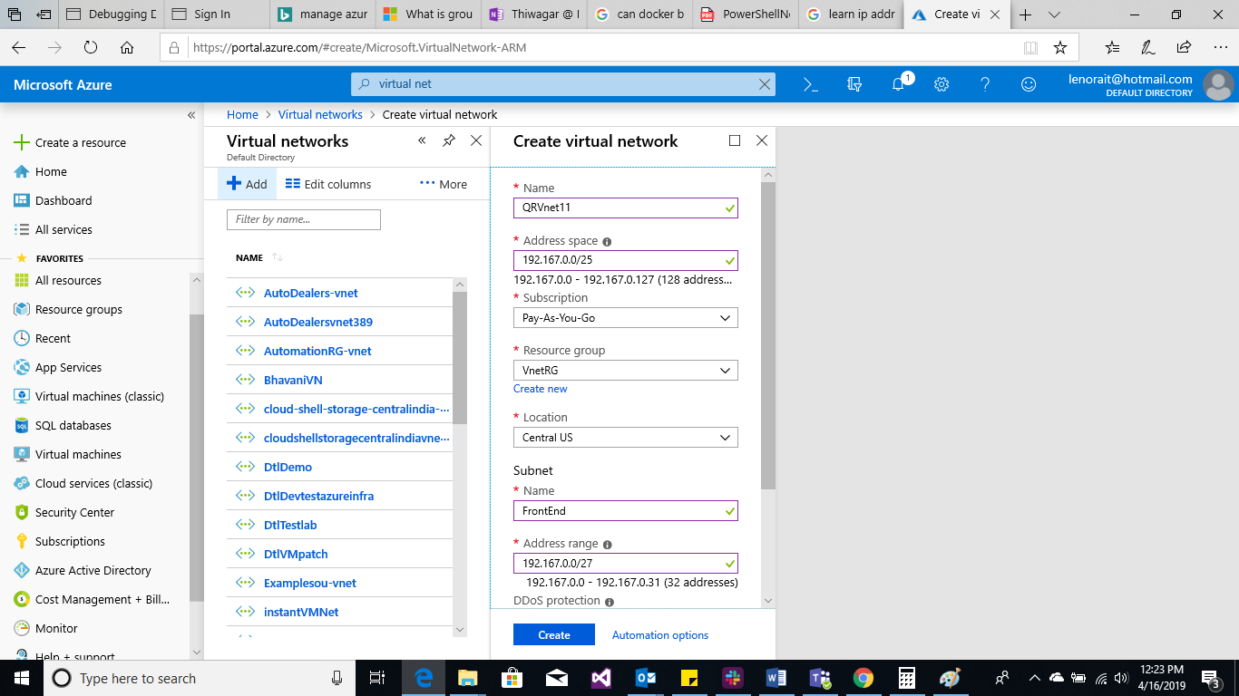

Created a Vnet with 128 IP addresses and a subnet with 32 IP addresses.